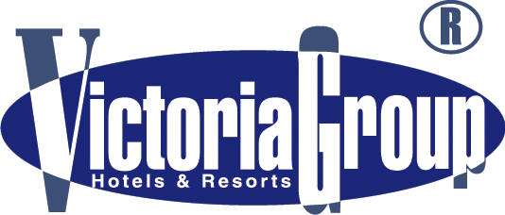
CHAIKA RESORT ****

ALL INCLUSIVE INFORMATION

FOOD AND BEVERAGE
RESTAURANT CHAIKA

Breakfast – 07.00 – 10.00
Buffet – standard buffet table, warm and cold dishes, broached non-alcoholic and warm beverages.

Lunch – 12.00 – 14.00
Buffet – standard buffet table, warm and cold dishes, desserts, fruits, ice cream, broached non-alcoholic,
low-alcoholic drinks.

Dinner – 18.00 – 21.00
Buffet – standard buffet table, warm and cold dishes, desserts, ice cream, broached non-alcoholic and
low-alcoholic beverages. 2 thematic evenings are offered weekly.

SNACKS AND BEVERAGES

RESTAURANT METROPOL – 10.00 – 22.00
Buffet – light snacks, confectionary, Bulgarian alcoholic and non-alcoholic drinks,
broached beer, cocktails and warm beverages.

LOBBY BAR METROPOL – 10.00 – 23.00
Bulgarian alcoholic and non-alcoholic drinks, broached beer, cocktails and warm beverages

POOL BAR CHAIKA – 10.00 – 18.00
Bulgarian alcoholic and non-alcoholic drinks, broached beer, cocktails and warm beverages

POOL BAR ARCADIA – 10.00 – 18.00
Bulgarian alcoholic and non-alcoholic drinks, broached beer, cocktails and warm beverages

Final order before 10.45 PM!!!

IRISH BAR – 10.00 – 23.00
Payable Bar & Grill

POOL
Sunshades / Sun-beds – free of charge for hotel guests/limited spaces

ADDITIONAL PAID SERVICES

SAFE
Purchased at reception – BGN 7.00 per day.The service is available only for the entire duration of the stay.

PARKING
Paid on arrival – BGN 12.00 per day. Limited spaces

Other: Telephone, SPA Center, sauna, jacuzzi, massage, Turkish bath, aromatherapy, hairdresser’s, manicure, Internet, taxi, rent-a-car, doctor, laundry and dry cleaning, billiards, WI - FI - in rooms, water sports on the beach.
IMPORTANT: All ALL INCLUSIVE Tourists Must Wear Their Plastic Bracelets!

BRACELETS MUST BE RETURNED WHEN LEAVING THE HOTEL! LOST BRACELET - FINE OF BGN 30.

